PostgreSQL Task 1: Database Architecture

Global Retail Superstore Sales - Tamar Tutisani
Module: Introduction to DWH and ETL – Part 2 (PG_DWH)

Task 1: Create New Database
What Was Done
Connected to the default postgres database and created a new database named test_db.
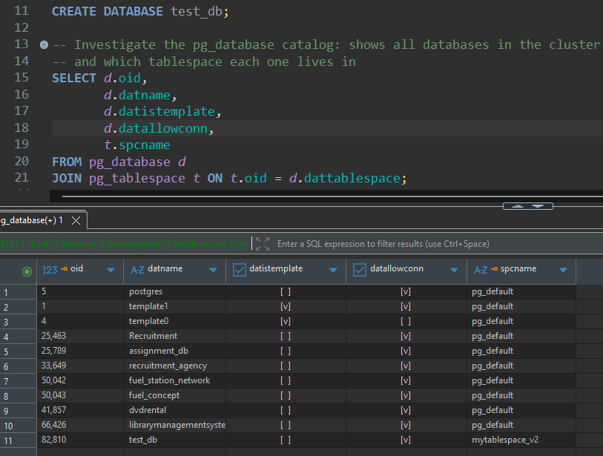

Key observations from the query result:
- test_db appears with datistemplate = false and datallowconn = true, it is a regular user database, not a template.
- spcname = pg_default, meaning test_db is stored in the default tablespace (the PostgreSQL data directory).
- The system databases postgres, template0, and template1 are also visible, these are created automatically by initdb.
- template1 is the template used when CREATE DATABASE is called; any objects in template1 are copied to every new database.
- Every database in the cluster shares the same configuration files and listens on the same port, but objects in one database are inaccessible from another without a foreign data wrapper.

Task 2: Create New Tablespace
What Was Done
Created a new tablespace mytablespace pointing to a new directory, verified it in pg_tablespace, then moved test_db into it.
OS Step (terminal before SQL)
# Create the directory
mkdir "%USERPROFILE%\pg_tablespaces\tblspc_test"

SQL Executed
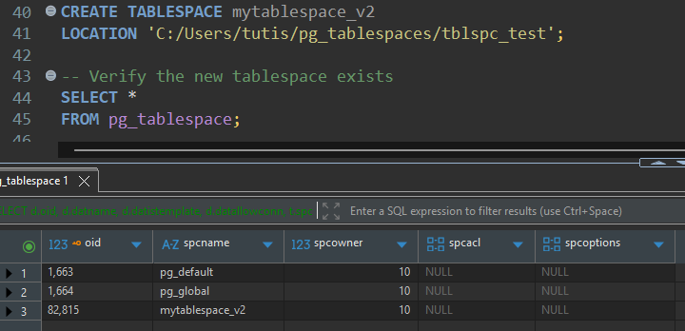
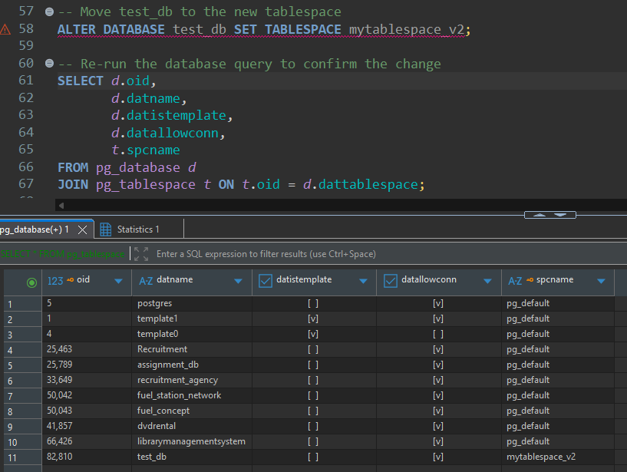
Key observations:
- After CREATE TABLESPACE, pg_tablespace shows three tablespaces: pg_global, pg_default, and mytablespace.
- pg_global holds cluster-wide system objects (roles, database definitions). pg_default is where user objects go by default.
- After ALTER DATABASE test_db SET TABLESPACE mytablespace, the pg_database query shows spcname = mytablespace for test_db.
- Physically, the database files have moved from the default PostgreSQL data directory into /var/lib/postgresql/data/tblspc_test.
- Tablespaces provide physical separation: administrators can direct heavy or archive tables to slower/cheaper disks while keeping hot data on fast SSDs.
- Unlike schemas, tablespaces are a physical concept, they map to actual filesystem paths. A tablespace cannot be used independently of the cluster (it depends on cluster metadata).

Task 3: Create New Schema
What Was Done
Connected to test_db, created schema labs, created table labs.person, inserted rows with explicit schema prefix, then used SET search_path to insert without the prefix.
SQL Executed
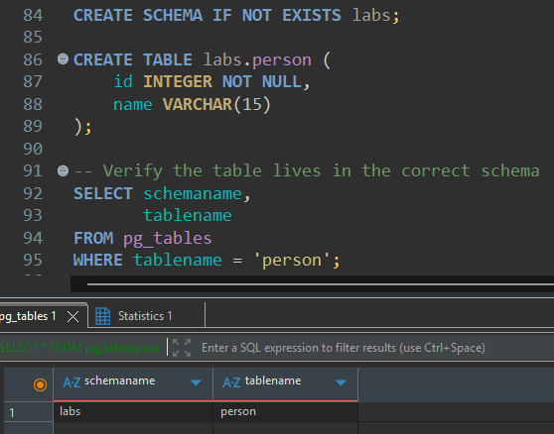
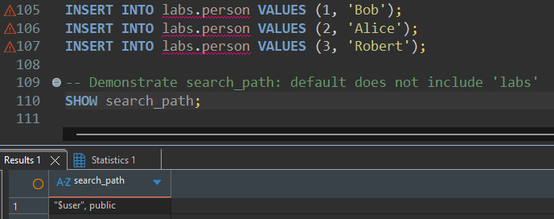
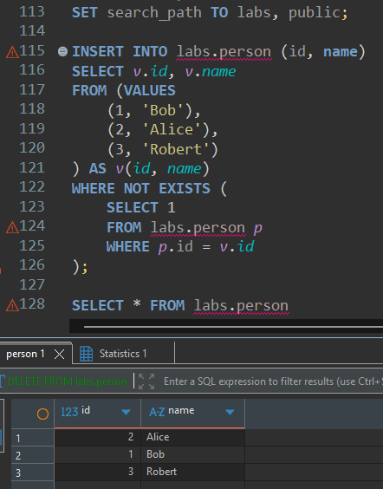
Key observations:
- pg_tables confirms the table lives in the labs schema, not in public.
- Before SET search_path, a bare INSERT INTO person would fail with "relation person does not exist" because search_path resolves against "$user" and public — neither of which is labs.
- After SET search_path TO labs, public, bare table references resolve to labs.person first, making the unqualified inserts succeed.
- Schemas provide logical separation within a database: different teams or modules can own separate schemas without name collisions.
- Unlike tablespaces (physical), schemas are purely logical — they have no impact on where data is stored on disk.

Task 4: Investigate MVCC
What Was Done
Used pageinspect to observe how PostgreSQL tracks row versions (xmin/xmax) during INSERT, UPDATE, DELETE operations, demonstrating Multi-Version Concurrency Control (MVCC).
SQL Executed
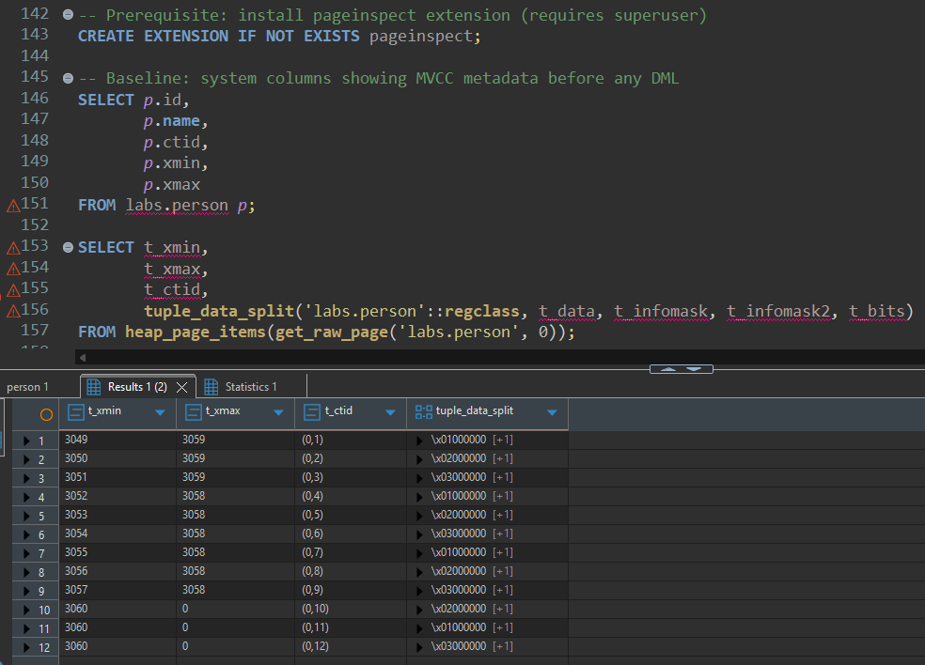
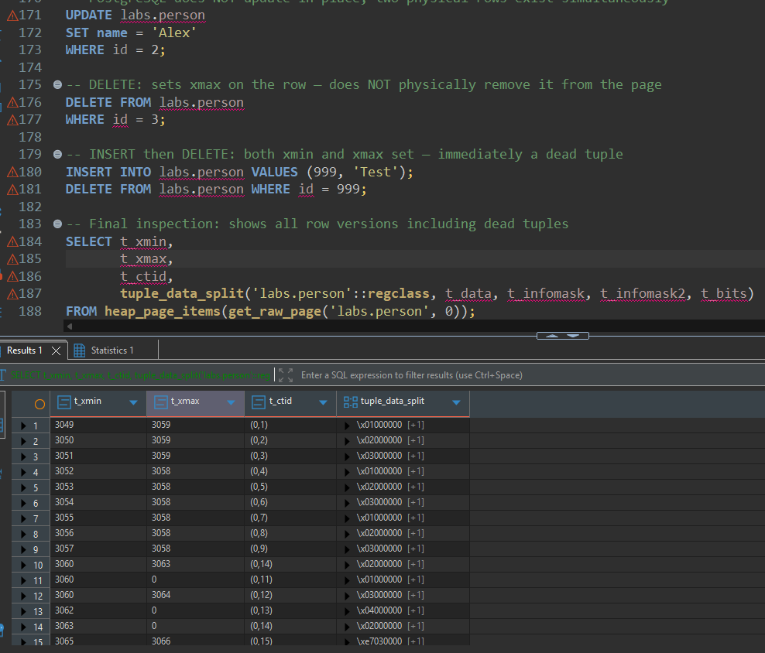
Key MVCC observations:
- xmin = the transaction ID that created this row version. xmax = the transaction ID that deleted or superseded this row (0 means still live).
- INSERT: new row gets xmin = current txid, xmax = 0. Visible to all transactions that started after this one committed.
- UPDATE: PostgreSQL does NOT update a row in-place. It marks the old row version with xmax = current txid (logical delete) and inserts a new row version with xmin = current txid. Both physical rows exist on the page simultaneously.
- DELETE: sets xmax on the row. The row is NOT physically removed, it remains on the page as a "dead tuple" until VACUUM runs.
- The id=999 row (inserted then immediately deleted) has both xmin and xmax set, it is immediately a dead tuple.
- ctid = (page_number, slot_number): the old Alice row has its ctid pointing to the new Alex row (the update chain).
- MVCC enables read consistency without locking: each transaction sees its own consistent snapshot based on xmin/xmax comparisons against its snapshot txid. Readers never block writers.

Task 5: Investigate VACUUM
What Was Done
Ran VACUUM and VACUUM FULL on the labs.person table and observed the physical impact on dead tuples and disk space using heap_page_items.
SQL Executed
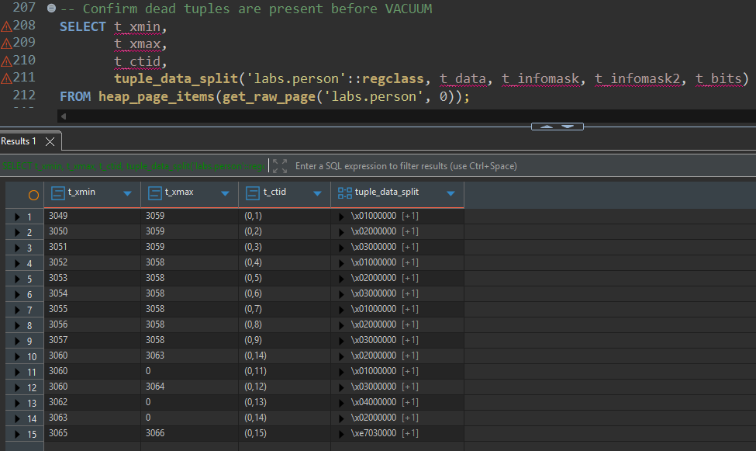
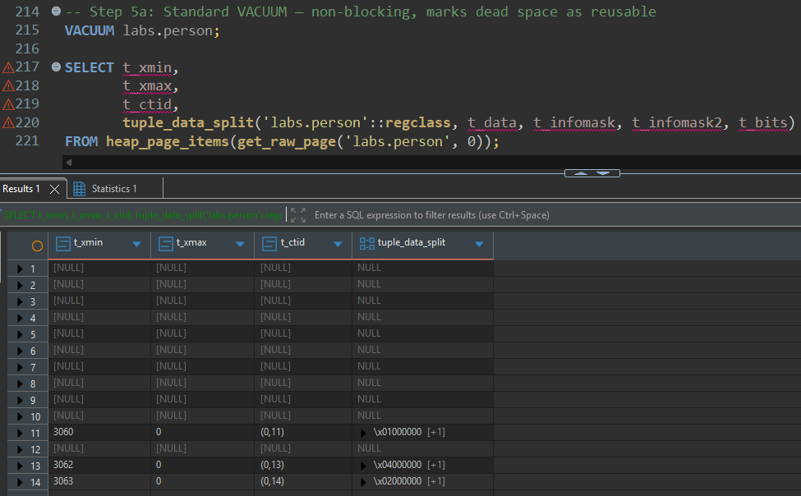
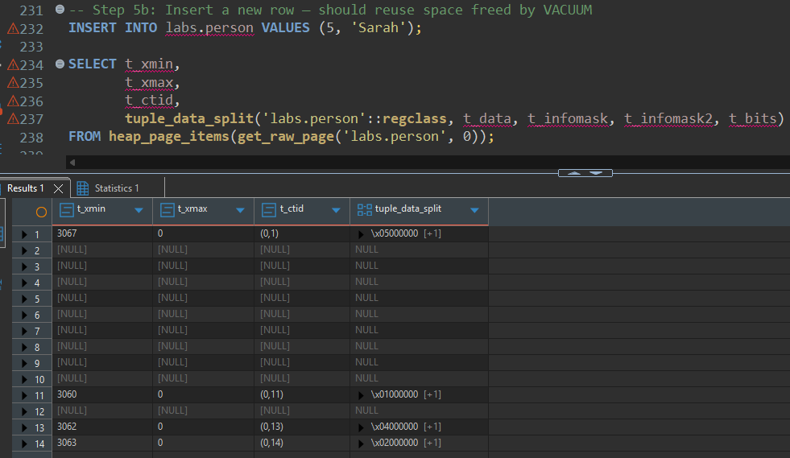
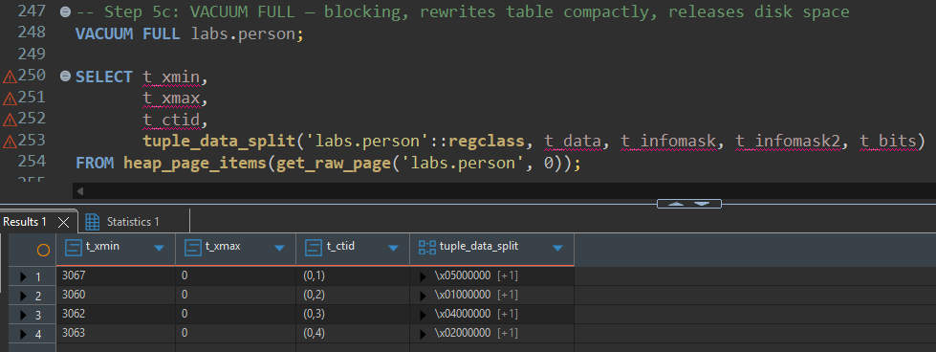
Key VACUUM observations:
- Before VACUUM: heap_page_items shows dead tuples (rows with xmax set and committed). These are invisible to normal SELECT queries but physically occupy space.
- After VACUUM: dead tuple slots are removed from the item pointer array. The page file size on disk does NOT shrink — the freed space is tracked in the Free Space Map (FSM) and reused for future inserts.
- After INSERT of Sarah: the new row may occupy a previously freed slot (lower ctid number), confirming that VACUUM correctly marks space as reusable.
- After VACUUM FULL: the table is completely rewritten into a new, compact file. Disk space is returned to the OS. ctid values restart from (0,1). Dead tuples are fully eliminated.
Comparison summary:
Property | No VACUUM | VACUUM | VACUUM FULL
Dead tuples removed | No | Yes | Yes
Disk space released to OS | No | No (reusable internally) | Yes
Blocking | N/A | Non-blocking | Exclusive lock
Table rewritten | No | No | Yes
Suitable for production | No (bloat grows) | Yes (routine) | Maintenance windows only
Run automatically | N/A | Yes (autovacuum) | Never (manual only)

- AUTOVACUUM: PostgreSQL runs standard VACUUM automatically in the background based on configurable thresholds (number of dead tuples). It is recommended to keep autovacuum enabled. VACUUM FULL is never run automatically.
- Why DELETE does not free space immediately: Postgres uses MVCC — a DELETE only sets xmax, so concurrent transactions that started before the delete can still see the old row via their snapshot. Physical removal before all such snapshots expire would break read consistency.

